St. Michael’s School News!

October 2022

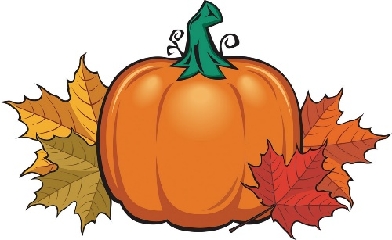



**The St. Michael’s School Fall Rummage Sale is set for October ­2-7, 2022.Tasha Thomas (218-841-0296) and Crystal Speer (218-261-0646) are chairing the sale. Set up begins Sunday, October 2nd at 1:00 - 7:00 p.m. and continues Monday and Tuesday 8:00 a.m.-7:00 p.m. The rummage sale runs Wednesday, October 5 from 8:00 a.m.- 7:00 p.m.; Thursday, October 6 from 8:00 a.m. – 7:00 p.m.; and Friday, October 7 from 8:00 a.m.- 1:00 p.m. with Clean-up to follow from 1:00-4:00 p.m. Donations will be accepted Sunday and Monday!**

**The fall and spring rummage sales are major fundraisers for our school. Money raised from the rummage sale will go directly into the school’s operating budget. Many volunteers are needed to make it a success. If you haven’t already, please sign up for a time to come in, or just stop by to help out when you can. Not only is it a great way to meet your volunteer hours, but it is also a great way to get to know the other parents and families at St. Michael’s School. Many hands lighten the load!**

Fire Prevention Week

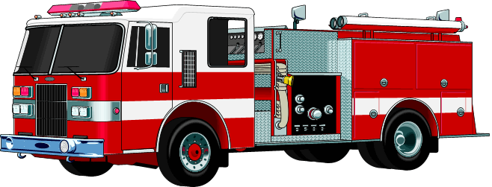

**Fire Prevention Week is October 2-8, 2021. Please remember to thank our local fire department.**

St. Joseph’s Beaulieu Appreciation

**Michael’s School will be showing our appreciation for parishioners at St. Joseph’s Beaulieu on Sunday, October 16th. We will also provide hospitality in the St. Joseph’s Social Hall following Mass. St. Joseph’s Mass sign-up sheets are attached to the newsletter. Please fill it out and turn it in to the school office by October 7th.**

Living Rosary

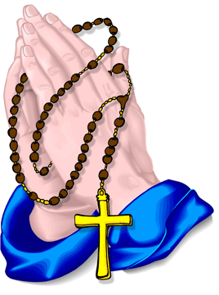

**On Wednesday, October 19, 2022 at 1:30 p.m. St. Michael’s School will hold a Living Rosary in the church social hall. Everyone is invited and encouraged to attend!**

Vision and Hearing

**St. Michael’s School students will have Vision and Hearing Screenings on Monday, October 10th starting at 8:30 a.m. Please make sure students who wear glasses have them on that day. We are looking for a couple volunteers to help out with screening. Please let the school office know if you are available.**

NO SCHOOL

**St. Michael’s will not have school on Thursday, October 20 or Friday, October 21 for MEA Break.**

Parish Mission

**Parish Renewal Mission: Fr. Lon Knold OMI**

**A Parish Renewal (Mission) is a time of listening and reflection for those who wish to be more faithful disciples of Jesus Christ. The Missionary Oblates of Mary Immaculate (OMI’s) will conduct a five-day Renewal (Mission) in our parish from October 23rd - October 27th, 2022. During the mission, students are invited to attend Mass each school day at 8:30 a.m. Everyone is welcome to join us for Mass and is encouraged to attend the evening sessions. Watch the St. Michael’s/St. Joseph’s bulletins for more information.**

Mahnomen Public Library Events

**The Mahnomen public library is excited to offer upcoming events.**

**Per Spelman Had a Cow: 4:30 p.m. Thursday, October 20th Storyteller, Arna Rennan will tell the tale of Per Spelman the real person behind the song. All Ages**

**Dream Catcher Workshop: 12:00 p.m. Saturday, October 29th Join artist Christy Goulet for a workshop bringing the artistry of creating dream catchers to life**

Calendar Raffle Winners

**Calendar Raffle $25 winners for the month of September were: Victoria Keller, Cynthia Schlick, Kassie Wadena, and Rose Colligan. Congratulations!**

Memorials

**St. Michael’s received memorials and honorariums during the month of September for: Sylvester Schoenborn, the Bisek Memorial Scholarship, and in honor of Kathy Thorpe.**

Halloween Parties

**The St. Michael’s School 6th graders will be building their annual haunted house for students to go through on Friday, October 28th. We will also be having our classroom Halloween parties on October 28th. Please send costumes for the 28th.**

Pastor Appreciation Day

**Sunday, October 9th is Pastor Appreciation Day. Take time to remember your pastor and thank them for all they do for your faith community.**

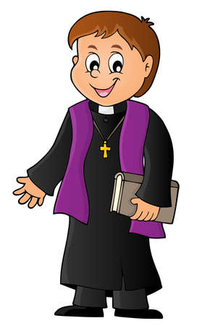

Dates to Remember

**Oct. 2- Rummage Sale set up 1:0 p.m. Oct. 3/4- Rummage Sale Set up 8:00 a.m.-7:00 p.m. Oct. 5-6- Rummage Sale 8:00 a.m.-7:00 p.m. Oct. 8- Rummage Sale 8:00 a.m.-1:00 p.m. Clean-up Oct. 9- Confirmation Oct. 11- Advancement Mtg. 6:00 p.m. Oct. 14- Mass 8:30 a.m. Oct. 16- St. Joseph’s Appreciation Mass 8:30 a.m. Oct. 18- Advisory Council 5:30 p.m. (Mrs. Kozitka) Oct. 19- Living Rosary 1:30 p.m. Oct. 20-21- MEA NO SCHOOL Oct. 23-27- Parish Renewal Mission Oct. 27- Principal Meeting (Mrs. Chalich Gone) Oct. 28- Mass 8:30, Halloween Parties/Haunted House Oct. 30- Halloween/ Trunk or Treat Nov. 1- Mass 8:30 Nov. 2- Mass 8:30/Cemetery Visit 9:00 Nov. 4- End of 1st Quarter /MNSAA Mtg. Nov. 5- Festival of Crafts Nov. 7- No School**