St. Michael’s School News!

October 2025

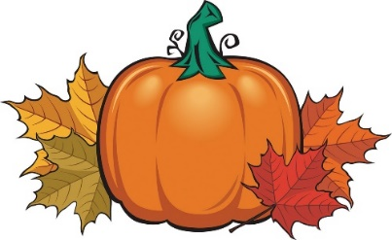



**The St. Michael’s School Fall Rummage Sale is set for October 5- October 10, 2025. Megan Askelson (PTC President) is chairing the sale. Set up begins Sunday, October 5 from 1:00 - 7:00 p.m. and continues Monday and Tuesday 8:00 a.m.-7:00 p.m. The rummage sale runs Wednesday, October 8 from 9:00 a.m.- 6:00 p.m.; Thursday, October 9 from 9:00 a.m. – 6:00 p.m.; and Friday, October 10 from 9:00 a.m.- 12:00 p.m. with Clean-up to follow from 12:00-4:00 p.m. Donations will be accepted Sunday and Monday Only! At this time, we do not have anyone signed up to work the sale on Saturday.**

**Many volunteers are needed to make it a success. If you haven’t already, please sign up for a time to come in, or just stop by to help out when you can. Not only is it a great way to meet your volunteer hours, but it is also a great way to get to know the other parents and families at St. Michael’s School. Many hands lighten the load!**

NO SCHOOL

**St. Michael’s will not have school on Thursday, October 16 or Friday, October 17 for MEA Break.**

Fire Prevention Week

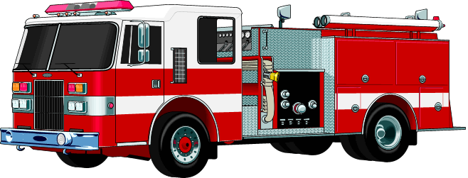

**Fire Prevention Week is October 5-11, 2025. Please remember to thank our local fire department.**

St. Joseph’s Beaulieu Appreciation

**Michael’s School will be showing our appreciation for parishioners at St. Joseph’s Beaulieu on Sunday, October 26th. We will also help provide hospitality following Mass. St. Joseph’s Mass sign-up sheets are attached to the newsletter. Please fill it out and turn it into the school office by October 10th.**

Pastor Appreciation Day 

**Sunday, October 12th is Pastor Appreciation Day. Take time to remember your pastor and thank them for all they do for your faith community.**

Round Dance

**Monday, October 13th St. Michael’s School students will be attending the Indigenous Peoples Day Round Dance at Mahnomen Public School.**

Living Rosary

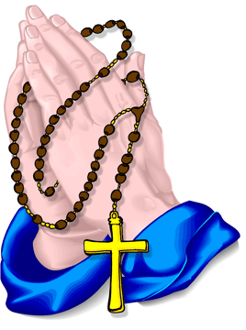

**On Wednesday, October 15th, 2025, at 1:30 p.m. St. Michael’s School will hold a Living Rosary in the church social hall. Everyone is invited and encouraged to attend!**



**“Pumpkin Painting Night” Community Family Fun Night Thursday, October 9, 2025 5:30-7:00 p.m. St. Michael’s School**

**All supplies will be provided! Supper will be served!**

**Open to all families with Children Ages Birth through Elementary RSVP: St. Michael’s School 218-935-5222**

Halloween Parties

**The St. Michael’s School 6th graders will be building their annual haunted house for students to go through on Friday, October 31st. We will also be having our classroom Halloween parties on October 31st. Please remember costumes need to be school appropriate and students should be able to put their own costume on. We will be having Mass and Cemetery Visits on October 31st also. Please don’t send your child to school wearing a costume.**

Conferences

St. Michael’s School conferences will be held on Wednesday, November 5, 2025. **The** **Conference Schedules is included with the newsletter.** Conferences are a time for parents to visit with their child’s teacher about their progress, and all they have been learning about this year. **Please make every effort to attend your child’s conference in person**. If you are unable to make the arranged conference time, please contact the school office (935-5222) to make other arrangements.

Thanksgiving Pie Sale



The St. Michael’s School Thanksgiving Pie Sale is **Friday, November 21,** **Saturday**, **November 22 and Sunday, November 23, 2025.** This fundraiser is a wonderful service to our community. Come out and spend some time making pies and visiting with other parents. **Pie sale information is included with your newsletter. Please begin selling pies now so we have a good estimate of the number of pies needed. Check your calendars and sign up for a time to come and help!**

Christmas Wreath Sale 

**St. Michael’s School will again be selling Christmas Wreaths $28.00 and Swags for $25.00 each. We have 100 Wreaths and 10 Swags on order. Wreaths and Swags will be available to pick up on Saturday, November 22nd and Sunday, November 23rd during the pie sale. Please begin selling wreaths now payment for the wreaths and swags can be made now or at the time of pick up.**

Calendar Raffle Winners

**Calendar Raffle $50 winners for the month of September were: Don Eveslage, Elmer Schoenborn, Al Bauer, and Bonnie Spaeth. Congratulations!**

Shed Raffle Winner

**Congratulations to Tim Netland who won the Shed Raffle donated by Ahmann Construction. The Shed Raffle raised $7,140.00 for our St. Michael’s School operating budget.**

Dates to Remember

**Oct. 1- Faculty Mtg. Oct. 3- Feast of St. Michael Mass; Mid-Term Oct. 5- 7- Rummage Sale Set up Oct. 7- Advancement Mtg. 6:00 p.m. Oct. 8-10- Rummage Sale 9:00 a.m. -6:00 p.m. Oct. 9- Family Fun Night 5:30-7:00 p.m. Oct. 10- Mass 8:30 a.m. Oct. 12- Pastor Appreciation Day Oct. 13- Indigenous People/Columbus Day; Round Dance Oct. 15- Living Rosary 1:30 p.m. Oct. 16-17- MEA NO SCHOOL Oct. 21- Advisory Council Mtg. 5:30 p.m. Oct. 22- Self-Study Mtg. 3:15 p.m. Oct. 24- Mass 8:30 a.m. Oct. 26- St. Joseph’s Mass 8:30 a.m. Oct. 29- Self-Study Mtg. 3:15 p.m. Oct. 30- Principal Mtg. Oct. 31- Mass/Cemetery Visit; Halloween; End of 1st Qtr.**