St. Michael’s School News!
October 2026
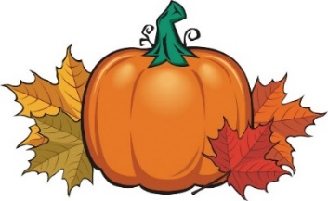

The St. Michael’s School Fall Rummage Sale is set for October 4- October 10, 2026. Set up begins Sunday, October 4 from 1:00 - 7:00 p.m. and continues Monday and Tuesday 8:00 a.m.-7:00 p.m. The rummage sale runs Wednesday, October 7 from 9:00 a.m.- 6:00 p.m.; Thursday, October 8 from 9:00 a.m. – 6:00 p.m.; Friday, October 9 from 9:00 a.m.- 6:00 p.m. and Saturday, October 10 from 9:00 a.m.-12:00 p.m. with Clean-up to follow from 12:00-4:00 p.m. Donations will be accepted on Sunday and Monday Only!
Many volunteers are needed to make it a success. If you haven’t already, please sign up for a time to come in, or just stop by to help out when you can. Not only is it a great way to meet your volunteer hours, but it is also a great way to get to know the other parents and families at St. Michael’s School. Many hands lighten the load!
NO SCHOOL
St. Michael’s will not have school on Thursday, October 15 or Friday, October 16 for MEA Break.
Fire Prevention Week 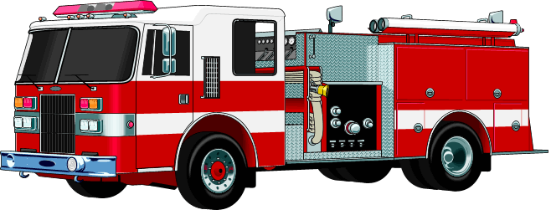Fire Prevention Week is October 4-10, 2026. Students will participate in activities here at school. Please remember to thank our local fire department.
Vision and Hearing Screening
St. Michael’s School will conduct Vison and Hearing Screenings with Norman-Mahnomen Public Health on Monday, October 19th. If your child has prescription glasses, please make sure they wear them to school.
St. Joseph’s Beaulieu Appreciation Mass
Michael’s School will be showing our appreciation for parishioners at St. Joseph’s Beaulieu on Sunday, October 25th. We will also help provide hospitality following Mass. St. Joseph’s Mass sign-up sheets are attached to the newsletter. Please fill it out and turn it into the school office by October 9th.
Pastor Appreciation Day 
Sunday, October 11th is Pastor Appreciation Day. Take time to remember your pastor and thank them for all they do for your faith community.
Round Dance
Monday, October 12th St. Michael’s School students will be attending the Indigenous Peoples Day Round Dance at Mahnomen Public School.
Living Rosary 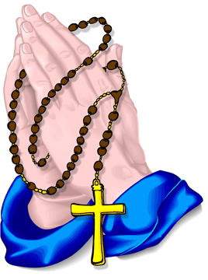
On Wednesday, October 14th, 2026, at 1:30 p.m. St. Michael’s School will hold a Living Rosary in the church social hall. Everyone is invited and encouraged to attend!

Halloween Parties
The St. Michael’s School 6th graders will be building their annual haunted house for students to go through on Friday, October 30th. We will also be having our classroom Halloween parties on October 30th. Please remember costumes need to be school appropriate, and students should be able to put their own costume on. Please don’t send your child to school wearing a costume.
Conferences
St. Michael’s School conferences will be held on Wednesday, November 11, 2026. The Conference Schedules is included with the newsletter. Conferences are a time for parents to visit with their child’s teacher about their progress, and all they have been learning about this year. Please make every effort to attend your child’s conference in person. If you are unable to make the conference time arranged, please contact the school office (935-5222) to make other arrangements.
Thanksgiving Pie Sale

The St. Michael’s School Thanksgiving Pie Sale is Friday, November 20, Saturday, November 21 and Sunday, November 22, 2026. This fundraiser is a wonderful service to our community. Come out and spend some time making pies and visiting with other parents. Bring a dish to share for potluck meals. Pie sale information is included in your newsletter. Please begin selling pies now so we have a good estimate of the number of pies needed. Check your calendars and sign up for a time to come and help! It is very important that we have at least 6-8 people working each shift throughout the sale to keep pie baking going.
Christmas Wreath Sale 
St. Michael’s School will again be selling Christmas Wreaths $28.00 and Swags for $26.00 each. We need to place our order by October 15th. I will order the minimum order necessary (100 wreaths and 10 swags), but need as many preorders as possible. Wreaths and Swags will be available to pick up on Saturday, November 21st and Sunday, November 22nd during the pie sale. Please begin selling wreaths now. Payment for the wreaths and swags can be made now or at the time of pick up.
Calendar Raffle Winners
Calendar Raffle $50 winners for the month of September were: John Hausner, Linda Blaser, Paula Herme, and Tom Jirik. Congratulations!
Dates to Remember
Oct. 4-6- Rummage Sale Set up Oct. 7-10- Rummage Sale Oct. 7- Faculty mtg. Oct. 9 – Mass 8:30 a.m. Oct. 12- Indigenous People Day/Columbus Day/ Wreath Preorders due Oct. 12-16- Fr. Andrew Gone Oct. 14- Living Rosary 1:30 p.m. Oct. 15-16- MEA NO SCHOOL Oct. 19- Vision and Hearing Screening Oct. 20- Advisory Council Mtg. 5:30 p.m. Oct. 23- Mass 8:30 a.m. Oct. 25- St. Joseph Mass 8:30 a.m. Oct. 30- Halloween Party Nov. 2 All Soul’s Day Mass 8:30 a.m./Blessing of Cemetery 9:30 a.m. Nov. 5- End of 1st Qtr./ Family Fun Night 5:30-7:00 Nov. 6- NO SCHOOL Teacher Workday

