St. Michael’s School November 2025 News
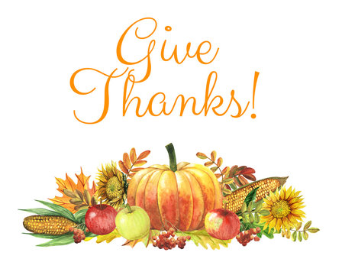
Field Trips
St. Michael’s students will be attending the play “The Ugly Duckling” at MSUM in Moorhead during the month of November. However, a date has not yet been finalized. Permission forms will be sent home when the date is confirmed. Students will be provided a sack lunch through the hot lunch program.
Thanksgiving Pie Sale
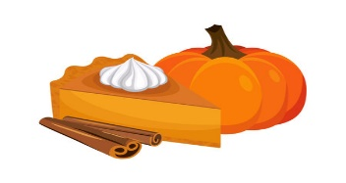
The St. Michael’s School Thanksgiving Pie Sale is Friday, November 21, Saturday, November 22 and Sunday, November 23, 2025. This fundraiser is a wonderful service to our community. Come out and spend some time making pies and visiting with other parents. Pie sale information has been sent home with your child and emailed to parents. Don’t forget to sign up for a time to come and help! We will be eating potluck both days, so bring a dish to share.

Christmas Wreath Sale 
The St. Michael’s School Christmas Wreath Sale is under way. We have 110 pre-ordered wreaths and 10 swags to sell. Order forms have been sent home and emailed. Wreaths will be available for pick up during the Pie Sale.

Fall Rummage Sale
Thank you to everyone who worked so hard to make the fall rummage sale another success: planning, setting up, working the sale, and cleaning up. Your volunteer time and commitment to St. Michael’s School is greatly appreciated. The rummage sale had a profit of $3,950.00. Great Work Everyone!

Festival of Crafts
St. Michael’s School will again be sponsoring the craft sale Saturday, November 8 from 9:00 a.m.-2:00 p.m. at the Mahnomen Public School. We are in need of parents to bring baked goods for the bake sale and help with set-up and clean-up. Baked goods should be labeled with name of product and if there are nuts in the baked goods. (Example: Chocolate Brownies with Walnuts). Baked goods can be dropped off at St. Michael’s school on Friday, November 7th or brought to the craft sale by 9:00 a.m. on Saturday, November 8th.
NO SCHOOL
There is no school on Monday, November 10, 2025 due to a teacher in-service.

.
Conferences
St. Michael’s School conferences will be held on Wednesday, November 5, 2025. Conference Schedules were sent home in October and are also included with the newsletter. Conferences are a time for parents to visit with their child’s teacher about their progress. Please make every effort to attend your child’s conference in person. If you are unable to make the arranged conference time, please contact the school office (935-5222) to make other arrangements.

Thanksgiving Meal
Parents and families are invited to join us for our Thanksgiving Meal on Wednesday, November 19, 2025. Menu: Turkey, Gravy, Stuffing, Mashed Potatoes, Green Beans, Dessert and Milk. Please see the attached invitation and return it to the school office by Friday, November 7th.
Thanksgiving B.I.N.G.O 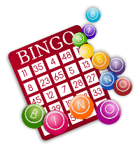
St. Michael’s School Thanksgiving B.I.N.G.O will be held on Wednesday, November 26, 2025. If you have prizes you would like to donate, please bring them to the school before that date, Students can purchase 1 card for $1.00 or 3 cards for $2.00. Money brought in from BINGO will be used to purchase a Christmas Gift for Fr. Andrew.
FYI
Our Christmas program is scheduled for Friday, December 12, 2025 at 7:00 p.m. Dress Rehearsal will be Wednesday, December 10 at 1:30 p.m. This is the same day as our Christmas meal. Please mark your calendar.
St. Michael’s School Christmas Vacation will be December 24, 2025 through January 2, 2026 School will resume on January 5th . This is the same schedule as the public school.
Calendar Raffle Winners
Congratulations to the October $50 Calendar Raffle winners: Sharon Litzau, Vince Vipond, Paige Ennen Scott McCollum. $250 Winner: Vince Vipond. Congratulations! Purchasing multiple tickets has its perks.

Dates to Remember
Nov. 4- Faculty Mtg. Nov. 5- Conferences Nov. 7- MNSAA Conference (Mrs. Chalich gone) Nov. 8- Festival of Crafts 9:00-2:00 Nov. 10- NO SCHOOL Teacher In-Service Nov. 11- Veterans Day Nov. 14- Mass 8:30 a.m. Nov. 18- Advisory Council Mtg. 5:30; Advancement Mtg. 6:30 Nov. 19- Thanksgiving Meal 11:30; Faculty Mtg. Nov. 21- Mass 8:30 Nov. 21-23- Pie Sale Nov. 26- Thanksgiving BINGO Nov. 27-28 NO SCHOOL Nov. 30- 1st Week of Advent

