Catholic Schools Week 2026 January 25-20, 2026
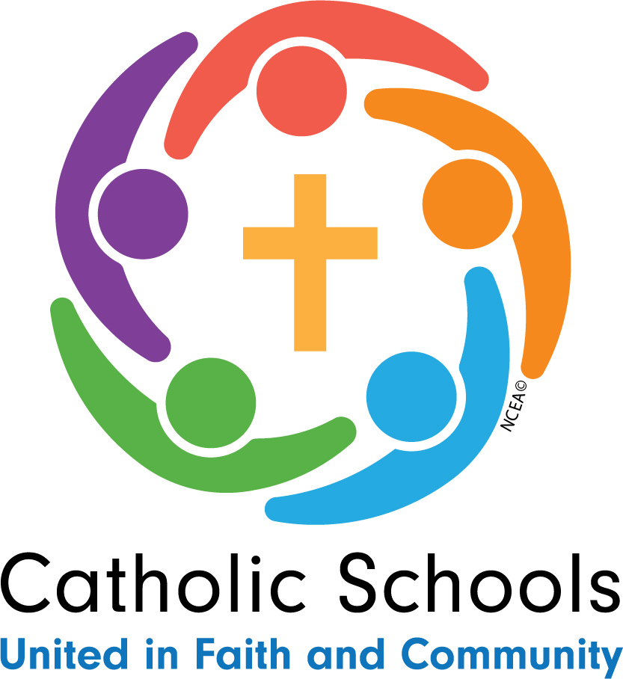
St. Michael’s School
Sunday 1/25/26 Celebrating your Parish “Spirit Day” dress in blue or red spirit wear or wear blue or red.
- Mass 10:30 a.m. St. Michael’s
- Appreciation Lunch for Parish with Door Prizes

Monday 1/26/26 Celebrating your Community “Crazy Hair Day” wear a crazy hair style.
- Make Thank You Cards for Community Volunteers and School Volunteers.


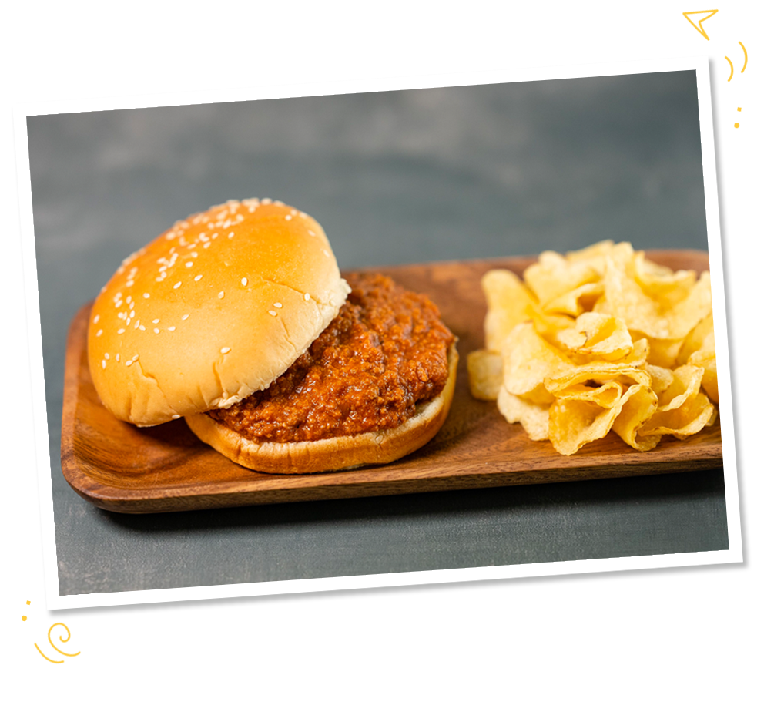
Tuesday 1/27/26 Celebrating your Students “Movie Character Day” dress like your favorite movie character.
- Student Awards
- Skiing (4-6) BINGO (K-2)
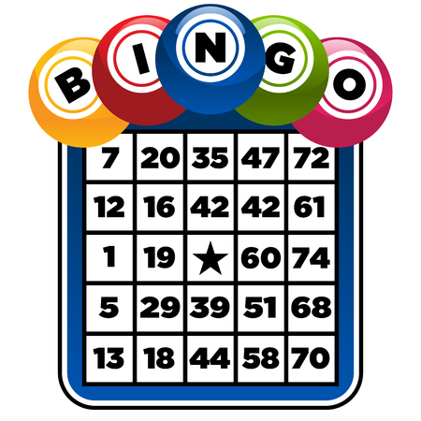
Wednesday 1/28/26 Celebrating the Nation “Mismatch Day” dress in mismatched clothes.”
- Game Day Afternoon



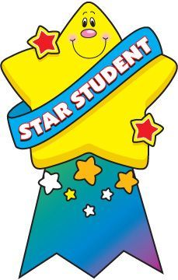


Thursday 1/29/26 Celebrating Vocations “Job Day” dress like your future Job.
- Teacher Swap

Friday 1/30/26 Celebrating Faculty, Staff and Volunteers “Pajama Day” wear your pajamas to school.
- Breakfast with Parents 7:45-8:15 a.m.
- Teacher Awards
- Movie Afternoon
