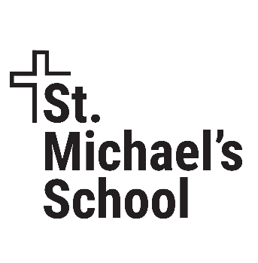
Faith. Family. Future.

BUILD THE FOUNDATION

PARISH MEETINGS AGENDA

- WELCOME
- FAITH. FAMILY. FUTURE. CAMPAIGN INTRODUCTION
  - Mission: In the presence of God, St. Michael’s School provides a nurturing environment, academic excellence, and spiritual growth in order to prepare children to live wisely and serve faithfully.
  - 93 years of success
  - 1,200 graduates
  - 95% high school graduation rate
- CAMPAIGN GOAL
  - Increase the endowment by $3,000,000 over the next five years
  - Resulting in $180,000/year in perpetuity
  - Supporting faith-based education for generations to come
- CAMPAIGN PROCESS
  - Feasibility study
  - Silent phase
  - Public phase
- CAMPAIGN PROGRESS
  - $3,000,000 Goal
  - $1,042,700 committed which is 34.75% of goal
  - Average gift commitment is $10,800
  - $261,500 in cash received so far
  - 97 donors
- GET INVOLVED: DONATE, VOLUNTEER, PRAY
  - DONATE—six ways to donate toward the campaign goal
    - One-time gift—cash, check, credit card
    - Pledge—faith pledge that may be spread over five years
    - IRA, stocks, or bonds. Make a gift of appreciated securities or a Qualified Charitable Distribution.
    - Grain or real estate—may provide specific tax advantages for farmers.
    - Wills or bequests—consider naming the School as a beneficiary in your will or estate planning.
    - Honorariums & memorials—gifts may be made in honor or memory of a loved one.
  - ASPIRATIONAL GIVING LEVELS
    - Pillar $500,000 or more. One secured and one needed
    - Builder $250,000 or more. Two needed
    - Cornerstone $100,000 or more. Two secured and three needed
    - Founder $50,000 or more. Three secured and six needed
    - Framer $25,000 or more. One secured and nine needed.
    - Architect $10,000 or more. One secured & fourteen needed
    - Beam $5,000 or more. Nine secured and eleven needed
    - Rafter <$2,500. Fifty secured and two-hundred needed
  - NAMED BURSES—CONTRIBUTE TO AN EXISTING BURSE OR ESTABLISH A NEW BURSE
    - Mary Ann Dentz
    - Jane Kozitka
    - Father Rick Lambert
    - Rita LaVoi
    - Jirik Family
    - David Jirik/Knights of Columbus #2573
    - Robert and Mary Jirik
    - McNamee Family
    - Altha and Sonny Spaeth
    - Diane Spaeth
    - Rosella Spaeth
    - Charles Stolka Family
    - Father Dave Super
    - Paul and Bernie Ahmann
  - VOLUNTEER
    - Advancement team
    - Call potential donors or stuff envelopes
    - Encourage others to participate
    - Be an ambassador for the campaign
    - Share campaign posts on social media
  - PRAY FOR THE SCHOOL AND THE CAMPAIGN
    - We are living in unprecedented times. The need for faith-based education has never been greater.
    - Please remember the school in your prayers. And we ask you to pray for the success of the campaign, as well as the part God might be asking you to play.
    - “…upon this rock I will build my church, and the gates of hell shall not prevail against it.” (From Matthew 16:18)
- SCHOOL ENROLLMENT AND GRANT FUNDING
- Q&A

